1.

import java.util.\*; import

java.Text.\*;

public class StringOperations {

public static void main(String[] args) {

i. Compare two strings lexicographically, ignoring case differences. String str1 = "Hello"; String str2 = "hELLO";

int result = str1.compareToIgnoreCase(str2);

if (result == 0) {

System.out.println("Strings are equal.");

} else if (result < 0) {

System.out.println("String 1 is lexicographically smaller than String 2."); } else {

System.out.println("String 2 is lexicographically smaller than String 1."); }

ii. Check whether a given string ends with the contents of another string. String mainStr = "Hello World";

String suffixStr = "World";

boolean endsWith = mainStr.endsWith(suffixStr);

if (endsWith) {

System.out.println("Main string ends with the given suffix string."); }

else {

System.out.println("Main string does not end with the given suffix string."); }

iii. Print current date and time in the specified format.

Date date = new Date();

SimpleDateFormat sdf = new SimpleDateFormat("dd/MM/yyyy HH:mm:ss"); String formattedDate = sdf.format(date);

System.out.println("Current date and time: " + formattedDate);

iv. Get the index of all the characters of the alphabet. String str =

"abcdefghijklmnopqrstuvwxyz"; for (char ch = 'a'; ch <= 'z'; ch++) {

int index = str.indexOf(ch);

System.out.println("Index of " + ch + ": " + index);

}

v. Replace each substring of a given string that matches the given regular expression with the given replacement.

String inputStr = "The quick brown fox jumps over the lazy dog. The quick brown fox jumps over the lazy dog.";

String regexStr = "fox";

String replacementStr = "cat";

String outputStr = inputStr.replaceAll(regexStr, replacementStr);

System.out.println("Output string: " + outputStr);

vi. Get a substring of a given string between two specified positions.

String input = "Hello World";

int startIndex = 1;

int endIndex = 6;

String output = input.substring(startIndex, endIndex);

System.out.println("Substring: " + output);

vii. Trim any leading or trailing whitespace from a given string.

String strToTrim = " Hello World ";

String trimmedStr = strToTrim.trim();

System.out.println("Trimmed string: " + trimmedStr); viii. Convert all the characters in a string to lowercase.

String inputString = "Hello World";

String outputString = inputString.toLowerCase();

System.out.println("Output string: " + outputString);

ix. Get the length of a given string. String lenStr = "Hello World"; int length = lenStr.length();

System.out.println("Length of the string: " + length);

x. Check whether two String objects contain the same data. String strA = "Hello World";

String strB = "Hello World"; boolean

areEqual = strA.equals(strB);

if (areEqual) {

System.out.println("The two strings contain the same data."); } else {

System.out.println("The two strings do not contain the same data."); }

}

}

2.

public class Account

{

private double balance;

public void Account(double initialBalance) {

this.balance = initialBalance;

}

public void Account() {

this.balance = 0;

}

public void addMoney(double amount) {

this.balance += amount;

}

public void withdrawMoney(double amount) {

if (amount > balance) {

System.out.println("Insufficient funds. A $5 penalty will be charged."); this.balance -= 5;

} else {

this.balance -= amount;

}

}

public double getCurrentBalance() {

return balance;

}

public double computeInterest(double interestRate) {

double interest = balance \* interestRate / 100;

this.balance += interest;

return interest;

}

public static void main(String[] args) {

Account myAccount = new Account();

myAccount.addMoney(500);

myAccount.withdrawMoney(200);

double balance = myAccount.getCurrentBalance();

System.out.println("Current balance: $" + balance);

double interest = myAccount.computeInterest(5);

System.out.println("Interest earned: $" + interest);

System.out.println("Updated balance after interest: $" + myAccount.getCurrentBalance()); }

}

Output:

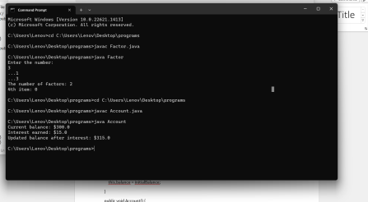

3.

public class NeedleHaystack {

public static int findNeedle(String haystack, String needle) {

int n = haystack.length();

int m = needle.length();

if (m == 0) {

return 0;

}

for (int i = 0; i <= n - m; i++) { if

(haystack.substring(i, i + m).equals(needle)) {

return i;

}

}

return -1;

}

public static void main(String[] args) {

String haystack = "sadbutsad";

String needle = "sad";

int index = findNeedle(haystack, needle);

System.out.println("Index of the first occurrence of the needle in the haystack: " + index); }

}

Output:

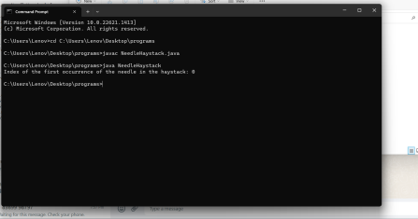

4.

importjava.util.\*;

class Factor { public static void main(String args[]) { try {

Scanner sc = new Scanner(System.in);

int count = 0, n = 100, i, j = 0, m = 4; int[]

a = new int[10];

System.out.println("Enter the number:"); n = sc.nextInt();

if (n <= 0) {

System.out.println("Enter valid number"); } else { for (i =

1; i <= n; i++) { if (n

% i == 0) { a[j] =

i;

System.out.println("..." + i);

count++; j++;

}

}

System.out.println("The number of factors: " + count); }

System.out.println(m + "th item: " + a[m - 1]); } catch (Exception e) {

System.out.println("Enter only numbers"); }

}

}

Out put:

